Targeted Lung Heath Check (TLHC) Programme
Communications toolkit
Contents
About 2
Short Summary 2
Longer summary 2
Targeted Lung Health Check Programme 2
Key Messages 3
Primary key messages to be included within all communications: 3
Secondary key message to be used when appropriate: 3
Visual Identity 3
Direct to Participant Assets 3
Website Copy 4
Newsletter Copy 5
Social Media Content 6
Social Media Assets 7
Infographic 8
Printed Resources 8
FAQs 9

About

Short Summary
The Targeted Lung Health Check Programme is a new service offered to those aged 55 to under 75 who are at a greater risk of developing lung cancer. Following an initial conversation with a health professional and, if needed, a simple scan, the Targeted Lung Health Check can identify signs of cancer at an early stage when it is much more treatable -saving lives.

Longer summary
The Targeted Lung Health Check Programme is a new service offered to those aged 55 to under 75 who are at a greater risk of developing lung cancer. Following an initial conversation with a health professional, those who have a higher chance of developing lung cancer will be offered a simple scan. This can identify signs of cancer at an early stage when it is much more treatable -ultimately saving move lives.
Lung cancer currently causes more deaths than any other cancer in the UK. There are often no symptoms at the earlier stages of lung cancer, and it is regularly diagnosed late. However, if caught early it’s much more treatable and the survival rate is much higher. Attending a Targeted Lung Health Check could save your life.
The Targeted Lung Health Check takes place in two steps. The first is a meeting or phone call with a specially trained health professional to assess your risk of lung cancer. If necessary, this is followed by a simple scan of the lungs using a low dose CT scanner. The scan will help identify any issues early, before symptoms occur, and when treatment has a much higher success rate.
What happens at a lung health check?
1. A health professional asks questions about your breathing, lifestyle, family and medical history. Height and weight measurements are also recorded.
2. Based on your answers, you may be invited for a simple lung scan. If you are not invited for a scan you will be discharged from the programme.
3. If the results of the scan show signs of anything concerning, you may be referred for further lung scans and treatment.

Southend Targeted Lung Health Check Programme
Southend patients are in the phase three group to benefit from a new national Targeted Lung Cancer Check Programme (TLHC). The programme is jointly hosted in Southend and Thurrock and has begun inviting people from across Southend to their attend a check. If you would like more information on the programme in Southend, visit the programme website: www.southendlunghealthcheck.nhs.uk

Key Messages

Primary key messages to be included within all communications:
• The Targeted Lung Health Check Programme helps save more lives by identifying lung cancer at an earlier stage, when it is much more treatable.
• When lung cancer is diagnosed early there are more options for treatment and a higher chance of survival.
• Targeted Lung Health Checks are offered to people aged 55 to 74+364 days, who are current or former smokers.

Secondary key message to be used when appropriate:
• The Targeted Lung Health Check Programme is initially being offered in areas of England with the highest lung cancer mortality rates.
• Other lung conditions can also be identified through the Targeted Lung Health Check Programme. If this happens, participants will be referred on for the appropriate treatment.
• Lung cancer causes more deaths than any other cancer in the UK. It is commonly diagnosed too late, due to there often being no symptoms at the earlier stages. Attending a Targeted Lung Health Check can help find issues early, often before symptoms occur.

Visual Identity
A visual identity has been developed for the programme to ensure a consistent and identifiable ‘look’. A simple logo has been produced which must be used alongside the NHS logo.
A range of assets have been created, some of which are linked to in this toolkit.

Direct to Participant Assets
A series of assets have been created to be used when contacting participants regarding Targeted Lung Health Checks. These can be found on the Southend TLHC website: Useful Information (southendlunghealthcheck.nhs.uk)

Website Copy
This web copy is designed to be used on public facing web pages.

Lung cancer is frequently diagnosed at a later stage than other cancers because often there are no signs or symptoms at an early stage. The Southend Targeted Lung Health Check Programme is a new pilot scheme designed to identify signs of cancer at an early stage when it is much more treatable -ultimately saving move lives.
The programme is being offered to people between the ages of 55 and 74 who are current or former smokers and at greater risk of lung cancer. Those eligible will be sent a letter to invite them for a Lung Health Check.
The Lung Heath Check finds out how well a participant’s lungs are working and hopes to identify problems early. Most of the time no issue is found, but if cancer or an issue with a participant’s breathing or lungs is found early, treatment could be simpler and more successful.
What happens during the check?
There are two main stages to a Targeted Lung Health Check. The first is an initial assessment with a health professional and the second, if necessary, is a simple scan of the lungs.
Initial assessment:
- If you are eligible, you will receive a letter inviting you for an initial Lung Health Check. At the Lung Health Check, you will be asked some questions about your breathing, overall lung health, lifestyle and family and medical history.
- Measurements of your height and weight will be taken.
- There are three possible results from your lung health check:
  - No problems found–the nurse may find nothing further to investigate and you will be discharged from the lung health check programme. We will write to your GP to tell them this.
  - Referral to your GP–if problem with your breathing or lung health are found, you might be referred to your GP. We will write to your GP so they know about the appointment.
  - Offered a scan of your lungs-whether you are offered a lung scan will depend on your chance of getting lung cancer now or in the future. We work out your risk from your lifestyle, medical and family history. The nurse will help you to choose whether the test is right for you. We will write to your GP so they know about the appointment.
Lung scan:
- The lung cancer scan uses a low-dose CT scanner to take a detailed picture of your lungs, to check for the early signs of lung cancer.
- The appointment will last approximately 30 minutes and you’ll have a chance to ask the nurse any questions.
- If your scan results come back with signs of anything concerning, you’ll be contacted with further information and referred for further tests and treatment.
- If a minor nodule is found, you may be asked to return for further scans at 3,6,12 or 24 months. If a nothing significant is found, you will be asked to return for a further scan 24 months later to confirm all is well.
- The lung scan is on a mobile truck and can take place in a variety of locations including your local hospital, supermarket or local community carpark.

For more information on the Targeted Lung Health Check Programme please visit the programme website: www.southendlunghealthcheck.nhs.uk/

Newsletter Copy
Newsletter copy can be used in public facing newsletters.
The NHS in Southend has launched Targeted Lung Health Checks to help diagnose lung cancer earlier and save more lives.
The Targeted Lung Health Check Programme is a new service offered to people aged 55 to 74 who are at a greater risk of developing lung cancer. Following an initial conversation with a health professional and, if needed, a simple scan, the Targeted Lung Health Check can identify signs of cancer at an early stage when it is much more treatable - ultimately saving move lives.
Sadly, due to there being few to no symptoms at an early stage, lung cancer is regularly diagnosed late. It currently causes more deaths than any other cancer in the UK, but if caught early, it’s much more treatable and the survival rate is much higher. Attending a Targeted Lung Health Check could save your life.
Offered to current or former smokers, the Lung Health Check starts with a check-up from a specially trained health professional If necessary, you will be offered a simple scan to take a picture of your lungs, to check for signs of lung cancer.
If you are eligible for a Lung Health Check, you will be sent a letter in the post.
For more information on the programme please visit https://www.southendlunghealthcheck.nhs.uk/

Social Media Content
The below social media posts provide a guide on the type of content which can be used to raise awareness of the TLHC across your social media channels.
Please use #NHSLungHealthCheck in all social content.
Example posts:
Do you live in Southend? Are you a current or former smoker? Aged between 55 and under 75? You may be eligible for a #NHSLungHealthCheck. To find out more, visit: www.southendlunghealthcheck.nhs.uk/ k
Did you know lung cancer often doesn’t show symptoms until the later stages? A Lung Health Check can spot issues early, often before you notice any symptoms, allowing for fast action to save more lives. To find out more, visit: www.southendlunghealthcheck.nhs.uk/
Your lungs work hard every minute of your life. As you get older it’s worth having them checked out. A #NHSLungHealthCheck can help to find problems early –often before you notice anything is wrong. To find out more, visit: www.southendlunghealthcheck.nhs.uk
Southend is offering #NHSLungHealthCheck which are helping to catch lung cancer early and save more lives. To see if you are eligible and to find out more, visit: www.southendlunghealthcheck.nhs.uk
Targeted Lung Health Checks help find problems early (often before you notice anything is wrong) and at a stage when treatment could be simpler and more successful - ultimately saving more lives. To find out more, visit: www.southendlunghealthcheck.nhs.uk
Did you know lung cancer is the UK’s biggest cancer killer? Often symptoms don’t show until a later stage. The #NHSLungHealthCheck programme identifies lung cancer early, when it’s more treatable, saving more lives. To see if you are eligible and to find out more, visit: www.southendlunghealthcheck.nhs.uk

Social Media Assets
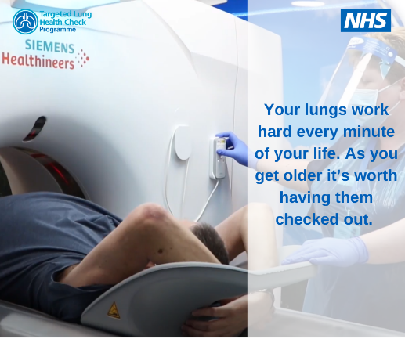
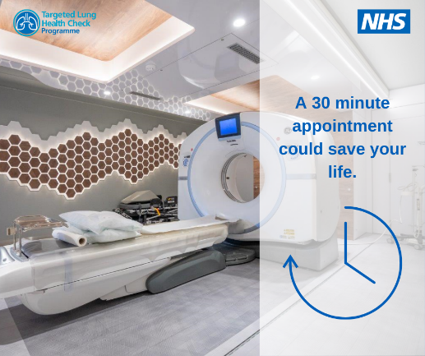
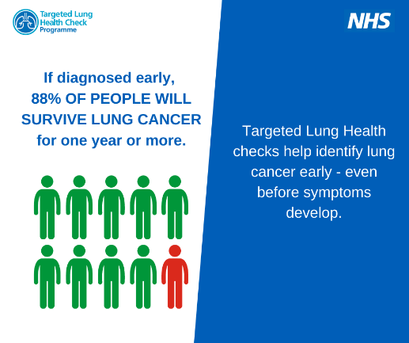
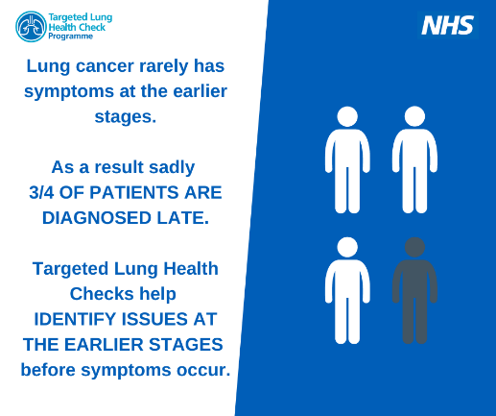
Ask Msepartnership.comms@nhs.net for original copies of these images to add to your own social media pages.

Infographic
This infographic is designed to explain the purpose and process of the TLHC in a way which is easy to understand.

Printed Resources
The following printed resources can be used within GP practices, local venues, community areas etc. to raise awareness of the programme.
Ask Msepartnership.comms@nhs.net for original copies of these resources

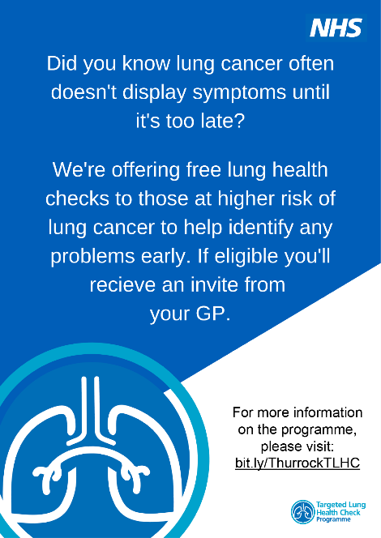
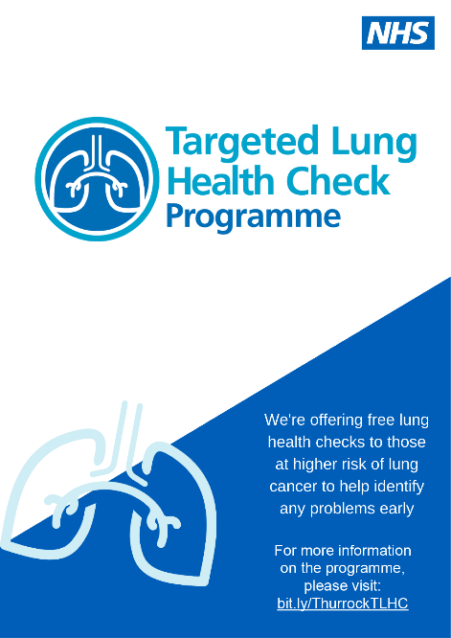
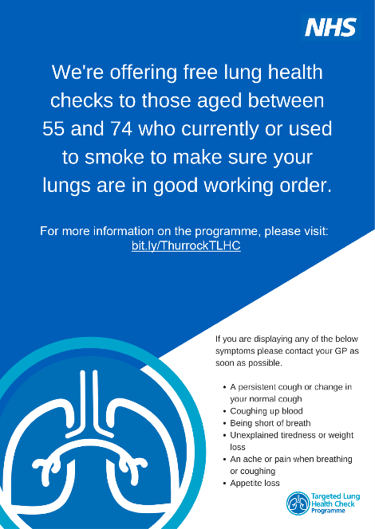

FAQs
Q. What is the aim of the Targeted Lung Health Check programme?
A. The aim of the programme is to detect lung cancer and disease early so that people can be treated sooner and more effectively – ultimately saving more lives. Lung cancer often has no symptoms in the earlier stages which can result in it not being found until the later stages when outcomes are less favourable.
Q. What is a Targeted Lung Health Check?
A. The lung health check takes part in two stages. The first is an appointment with a specially trained nurse to assess your risk level. If you are found to be at high risk of having lung cancer you will be invited to have a low dose CT scan so we can capture an image of your lungs and identify if there are any issues which need further investigation or treatment.
Q. Where will lung health checks take place?
A. The first phase will be a check-up which may be by phone, video call or in person. If you are invited to have a CT scan these will be carried out by radiographers on mobile units. The mobile units will be parked in community venues or supermarket car parks which have good transport links for ease of access.
Q. When will appointments be available?
A. Appointments will be arranged over the phone with you, they are usually within a two week window.
Q. What happens after a lung health check?
A. Should anything be identified either during the discussion with a nurse or from the CT scan, then you will be contacted by telephone or letter with the next steps. If you have any questions you can speak to the staff on site or visit: www.southendlunghealthcheck.nhs.uk
Q. Why is the Targeted Lung Health Check only being offered to smokers/past smokers in a certain age range?
A. The Targeted Lung Health Check is currently being offered to those most at risk of getting lung cancer. Data shows those between the age of 55 and 74+364 days who currently or previously smoked are at a higher risk than others of getting lung cancer. If you display any symptoms or have any concerns about your lung health you should book an appointment to see your GP straight away.
Q. When are the Targeted Lung Health Checks starting?
A. The lung health checks began in April 2022 and will continue until everyone has been invited, the programme will be completed by 2025.
Q. Do I have to get undressed if I need a CT Scan?
A. You may need to remove your coat, but you can leave your clothing on.
Q. Can I bring someone along with me to the appointment?
A. We have limited space on the CT scanning unit and not many places to wait, we would prefer if you came on to the unit alone – but if you have a carer or need an interpreter, then you can have them with you.
Q. Why isn’t it available in my area?
A. The Targeted Lung Health Check Programme is being rolled out across England. The areas with higher lung cancer mortality rates are being prioritised first and new locations will be available from April 2022. If you are worried about any of the below symptoms, please see your GP as soon as possible:
    - A persistent cough or change in your normal cough
    - Coughing up blood
    - Being short of breath
    - Unexplained tiredness or weight loss
    - An ache or pain when breathing or coughing
    - Appetite loss

